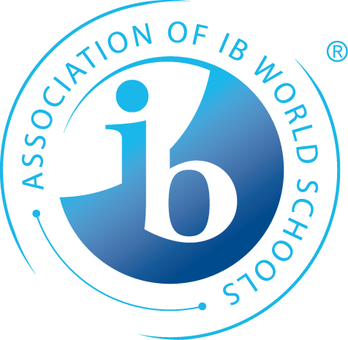
MYP Collaborative Sharing Sessions

Sponsored by GIBS, the Association of IB Schools in the Northeast United States

What: GIBS is sponsoring three different sharing sessions, to be held at the same school. Participants should choose one to attend!
MYP Science
MYP Math
MYP: New teachers

Who is invited: Up to five teachers per school/district are invited to attend each sharing session.

What will happen: This event will allow schools to send teachers to these three different sharing sessions. The facilitator for each session will contact participants ahead of time!

Where: Josiah Quincy Upper School
152 Arlington St.
Boston, MA 02116

When: Tuesday, November 27, 2018, from 9:30-1:30

A breakfast-y snack and lunch will be provided. Limited parking is available. Internet access will be provided.

Cost:
GIBS members: First two participants at no cost; each additional participant at $25.00
Non-members: $75.00 per participant
Register through your school’s MYP coordinator
or contact Jim Meyer, IB Coordinator, meyer.jqus@gmail.com
or (617) 635-8940
payments for additional participants to:
Dr. Robert Brooks, GIBS treasurer; PO Box 9457; 805 West Shore Road; Warwick, RI 02889

